NEW INDIAN EXPRESS/CHENNAI/11/04/2009
http://epaper.newindpress.com/NE/NE/2009/04/11/ArticleHtmls/11_04_2009_375_002.shtml?Mode=1

Kings of grasslands flying into the sunset
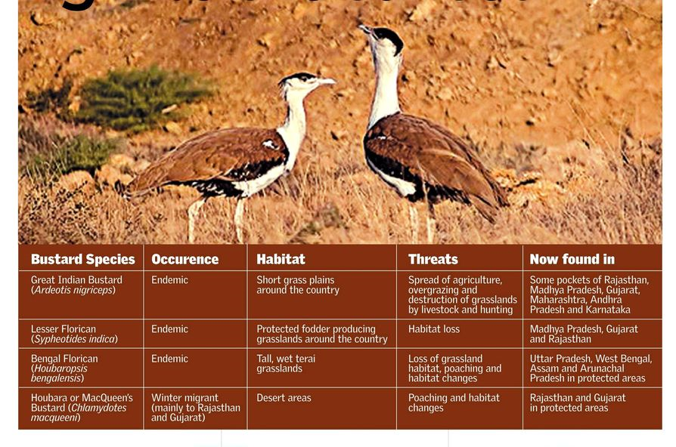
Blinkered conservation policies and neglected grasslands have reduced the population of the Great Indian Bustard to just over 500, says Kalyani N
t he Great Indian Bustard used to be the king of the grasslands in the country’s north. Now it’s scarcely visible anywhere in its range. Once it was numbered in the tens of thousands. Today, if the estimates are right, there are just over 500 of them left.

A report by the Bombay Natural History Society (BNHS) points out that the great Indian bustard is locally extinct from almost 90 per cent of its former range! The three resident species — the great Indian bustard, the lesser florican and the Bengal florican — are the most threatened bustards of the 22 species found in the world, according to the International Union for Conservation of Nature (IUCN). The danger extends even to the migrant species — houbara bustard.

The situation is dire even though all the four species of bustards have been placed in Schedule I of the Indian Wild Life (Protection) Act 1972, the highest degree of protection given.

The declining bustard population tells many stories — of blinkered conservation policies and neglected grasslands.

The health of an ecosystem can be gauged by the flagship species, the species that sits at the apex of the food chain. If the tigers are thriving, then the jungle is healthy and the system is in balance. Similarly, if the bustard is flourishing, that means the grasslands ecosystem is viable.

Grasslands are often overlooked in conservation strategies. They seem to be like unwanted stepchildren. In the BNHS report, its director Asad Rahmani writes, “Whenever wildlife protection is considered, the focus is invariably on forested habitats that need protection from felling of trees or removal of encroachment or other human use. Despite the fact that some of India’s most endangered wildlife inhabit grasslands, wetlands, coasts, rivers, and rural landscapes, these rarely find a place in conservation priority.” Not only are grasslands home to a diversity of species, they also absorb copious amounts of rainwater and play a vital role in the hydrology of an area. They are also of primary importance to pastoral, agrarian communities that rear livestock. Besides, the grass can be converted into biomass.

The thoughtless clearing of grasslands has not only affected bustard populations but also other highly threatened species such as the blackbuck, the chinkara, the rhinoceros, the wild buffalo and vulture and eagle species, besides a multitude of other birds, reptiles and mammals.

According to Dr Rahmani, protecting the greenlands could even lead to a larger solution — a new way of conducting wildlife conservation in India. “Landscape level planning would involve local communities and this in itself could provide the much needed new paradigm of wildlife conserva tion in India.” It is in fact the centuries-old, timetested traditional knowledge of local communities that can play an important role in grassland conservation.

Agriculture is the biggest threat to grasslands, especially overgrazing by livestock. India has one of the largest livestock populations in the world, with an estimated 540 million head, but the country lack a grazing policy, says Dr Rahmani.

“We consider livestock as dhan or money but what about the grasslands which keep this dhan alive? The government never pays attention to this aspect.” Large portions of grasslands have also been gobbled up for modern infrastructure and industrial demands and housing needs. According to Dr Rahmani, “The grasslands are the most neglected ecosystems in India.

They remain unprotected unless notified as protected under the WildlLife (Pro tection) Act, 1972 or the Indian For est Act, 1927.” After the initial enthusiasm about protecting bustard species in the 1980s, there has hardly been any interest. As a result, most of the bustard sanctuaries such as Karera, Sonkhaliya, Sorson, Rollapadu, Ghatigaon and Rannibennur are neglected.

Dr Rahmani says, “The IUCN resolution should force the Government of India to do something to save the bustards and the floricans and their habitat. Just as a resolution in 1969 helped ban tiger hunting and start Project Tiger.” Dr Rahmani pleads for a ‘Project Bustard’ on the same lines. This would entail concrete steps in conserving all four bustard species and their habitats. This would also involve the local communities.

The need of the hour is a national grazing and grassland policy, in which bustard conservation is centrally integrated.

